The Seven P's

of Breast Self-Examination
Know Your Body I Check for Changes I Early Detection Saves Lives

Inspect your breasts both in the mirror and lying down.
lrncludethe area of your breast
that extends to your armpit.
Move your three fingers
in a gentle, circular motion.

114i·i4Wiii
Feels tis!i-ue just
under the skin.

Mediumpressure
Feels a little deeper tissue.

- In the mirror: Look at the size,shape, and skin of your breasts. Check for any changes (dimpling, redness, swellirng, or nipple changes).
- Lying down: Breast tissue spreads
evenly,making it easier to feel changes.

- Don't just check the breast itself. Feel the entire area - from your collarbone to below your breast and over to your armpit (includlng the tailof Spence).

- Use the pads of your trnree middle
fingers (not your fingertips).
- Move in small, gentle circles, feeling for lumps, thickening, or other changes.
iJfo...iUWili
Feels the deep tissue near your chest wall.

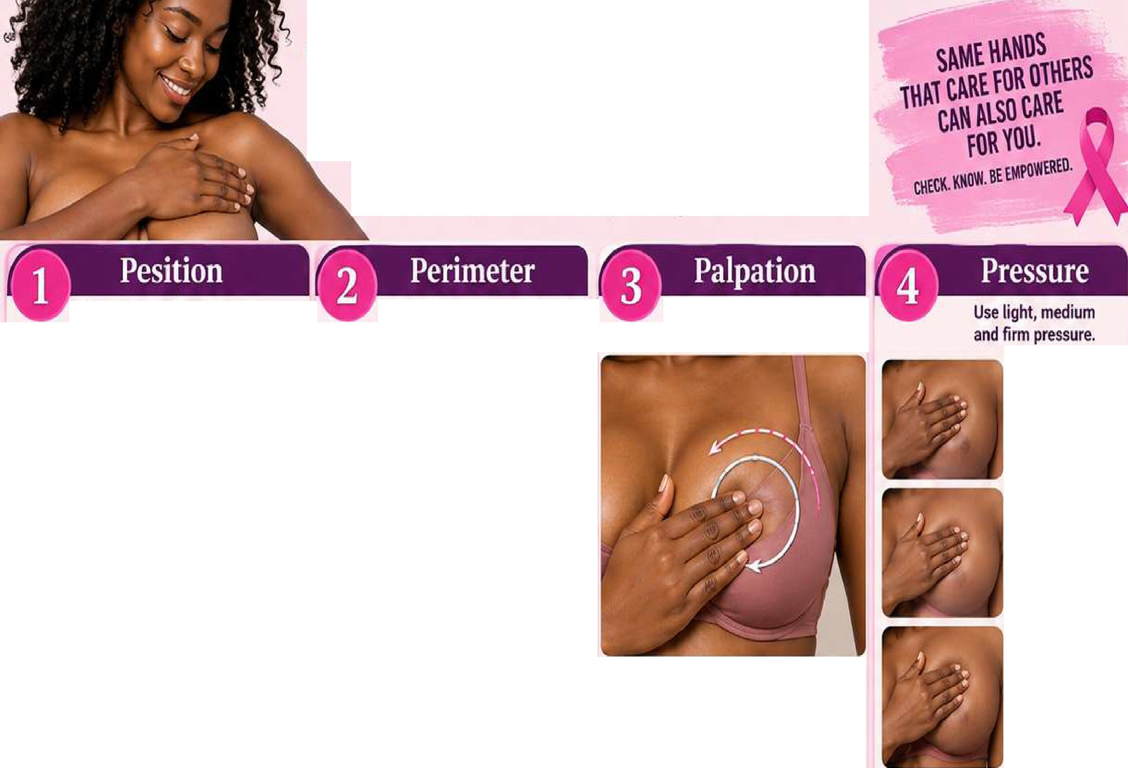
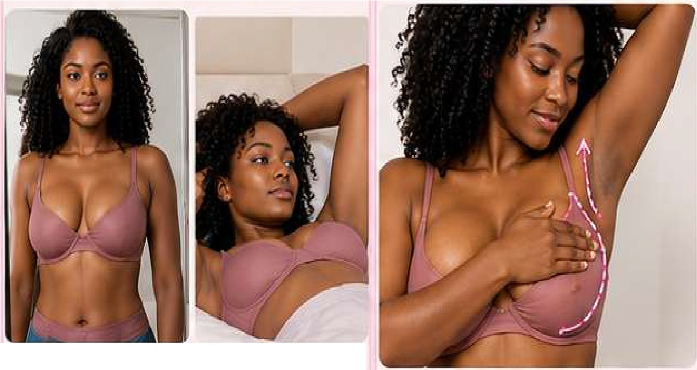
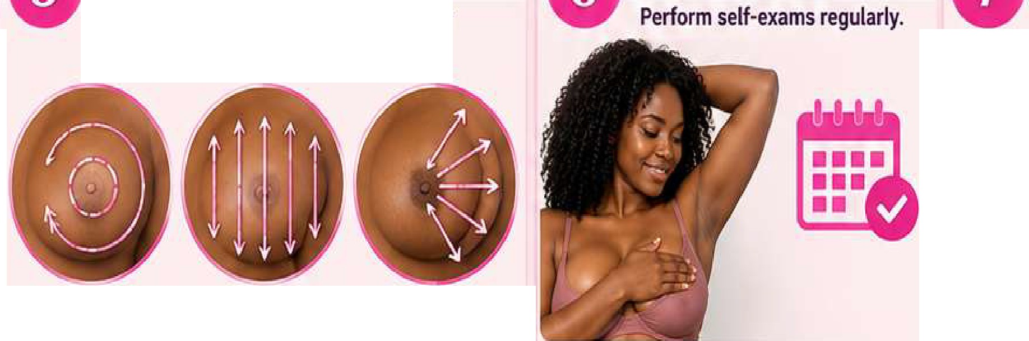
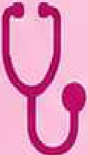

Start at the nipp!e Move in straight Imagine slices of and move outward lines from top to a pie, moving from incircles. bottom. the nippleoutward.
Use a pattern to make sure you cover
your entire breast.
Know what you'relooking for and
what to do if something seems unusual.
Knowwhat'snormal
for you.
- The iook and feel of your breasts.
- It'snormal for breasts to feel lumpy-what m11tters is a new or unusual change.
Bealert for changes such as:
- Changes in sizeor shape

rash on the skin
,
Circular
Up and Down
Wedge
discharge,or ten.demess)
doesn't go away
- Pain inone area that
- Nipplec�aL1ges (inversion
- Dimpling, redness or
- A new lumpor thickening

A Choose one pattern and use it every time
V so you don't miss any a.rea.

- Check your breasts once a month.
- The best time is a few days after your menstrualperiod, when your breasts are less likely to be swollen or tender.
- If you no longer have periods·,choose a consistent date each month.

If you notice anything unusual,
contact your healthcare provider promptly. Most changes arenot c.incer, but it's important to get them checked.

